SUTD 50.001 Introduction to Information Systems and Programming
Problem Set 3B

For all questions, please access the vocareum link found at eDimension for the starter code and to submit.
The Vocareum link is for submission only. Please work on the problems in Android studio, and this includes writing code for the test cases.
To prevent hard-coding, test cases used in Vocareum may be different from those provided here and will not be given to you.

There is only one question in this Problem Set.

This problem set is written to help you have an idea of what to expect for Final Exam Part 1.

In the Final Exam Part 1, there will be parts.

- Part A – write Java class(es). You will submit your answer to Vocareum (through the Schoolyear Exam browser during the exam).

- Part B – write the code for MainActivity.java. You will write your code on the question paper.

- Part C – conceptual questions. You will write your answer on the question paper.

Q1. [Programming Question] Java Programming and Android App
Background
Financial institutions sell instruments called “bonds” to borrow money from investors.

Bonds are sold at a selling price in dollars. In return, the institution promises two things:
- To buy the bond back from you at the face value (in dollars) a certain period of time later (called the “duration”, expressed in number of years)
- To pay you an interest payment (this is paid annually in dollars, i.e. once every year)

Investors evaluate the bonds by calculating the yield to maturity $r$, which is a function of the duration, the face value, the selling price and the interest payment.

There are two formulas for the yield to maturity $r$ based on the type of bond. The formulas below produce a decimal value of $r$ between 0 and 1.

“Zero Coupon Bonds” - If a bond has zero annual interest payment, the yield to maturity $r$ is calculated using the following formula:
$$r={\left(\frac{Face value}{Selling price}\right)}^{1/duration}-1$$

“Coupon-Paying Bonds” - If a bond has positive annual interest payment, the yield to maturity $r$ satisfies the following formula:
$$selling price=(interest payment)×\frac{1-{\left(\frac{1}{1+r}\right)}^{duration}}{r}+ \frac{face value}{{(1+r)}^{duration}}$$

For this formula, $r$ must be obtained by using an iterative numerical method.

Details of this numerical method are described here. First, we define
$$f\left(r\right)=selling price-\left(interest payment\right)×\frac{1-{\left(\frac{1}{1+r}\right)}^{duration}}{r}- \frac{face value}{{(1+r)}^{duration}}$$

In this test question, the interval bisection method is used to solve for the value of $r$ that makes $f(r) = 0$. The pseudocode is given below. Note that in step 1 below, the choice of $r_{up}$ and $r_{down}$ guarantees that the values of $f\left(r_{up}\right),f(r_{down})$ have opposite signs.

- Choose starting values of $r_{up}=1$ and $r_{down}=1×{10}^{-10}$
- Calculate $delta= r_{up}-$ $r_{down}$
- While $delta>1×{10}^{-5}$
  - Assign $r_{middle}=\frac{1}{2}(r_{up}+r_{down})$
  - Calculate $f\left(r_{middle}\right), f\left(r_{up}\right),f(r_{down})$
  - If $f\left(r_{middle}\right)$and $f\left(r_{up}\right)$ have the same sign, assign $r_{up}=r_{middle}$
  - If $f\left(r_{middle}\right)$and $f\left(r_{down}\right)$ have the same sign, assign$r_{down}=r_{middle}$
  - Calculate $delta$ as defined in step 2
- The result $r=\frac{1}{2}(r_{up}+r_{down})$

The Yield to Maturity for four different bonds are shown below.

Test Case | Selling Price | Face Value | Duration¹ | Interest Payment (annual) | Yield To Maturity  (4 d.p.)
1 | 900 | 1000 | 4 | 10 | 0.0374
2 | 1000 | 1000 | 1 | 10 | 0.0100
3 | 900 | 1000 | 1 | 0 | 0.1111
4 | 1000 | 1000 | 1 | 0 | 0.0000

Note 1. In actual finance terminology, this is called “tenor” or “term to maturity”. “Duration” has a different meaning for bonds, which we will not discuss here.
Part A – Writing the Bond Class (24 points)
Submit your answer to Vocareum to collect points to fulfil the coursework requirements

The starter code of Bond.java should contain the following statements.
public class Bond {

private double sellingPrice;
private double faceValue;
private double interestPayment;
private double duration;
private YieldCalculation yieldCalculation;

private Bond(double sellingPrice, double faceValue, double interestPayment, double duration){
this.sellingPrice = sellingPrice;
this.faceValue = faceValue;
this.interestPayment = interestPayment;
this.duration = duration;
}
}

YieldCalculation.java should contain the following statements, which you do not need to modify.
public interface YieldCalculation{

double yieldToMaturity (Bond bond);
}

TestBond.java contains example of how the requirements of this questions are met. You can determine what the output should be by reading the background section.

public class TestBond {
public static void main(String[] args){
Bond.BondBuilder bondBuilder = new Bond.BondBuilder();
Bond bond1 = bondBuilder.createBond();
bond1.setYieldCalculation(new WithCouponYield());
System.out.println("" + bond1.calculateYTM());
Bond bond2 = bondBuilder
.setDuration(1)
.setFaceValue(1000)
.setSellingPrice(900)
.setInterestPayment(0).createBond();
bond2.setYieldCalculation(new ZeroCouponYield());
System.out.println("" + bond2.calculateYTM());
}
}

The requirements are as follows.

- As the constructor is private, one way to instantiate the class Bond is to implement a static inner class BondBuilder that implements the builder design pattern. The method in BondBuilder that creates an instance of Bond using the constructor shown above is called createBond().
If none of the setters in BondBuilder are called, i.e.
Bond bond = new Bond.BondBuilder().createBond();
the instance of the Bond class that is returned has the following default values: The default value of the selling price and face value is 1000, the default interest payment is 10 and the default duration is 1.

- The class Bond should have getter methods for the instance variables sellingPrice, faceValue, interestPayment and duration.

- The constructor for the Bond class shown above should be modified to throw an IllegalArgumentException if sellingPrice, faceValue and duration are zero or negative, and when interestPayment is negative. This is the only modification that you need to make to the constructor shown above.

- The class Bond should have a setter method for the instance variable yieldCalculation, which is for objects that implement the YieldCalculation interface.

- The class Bond should have a method calculateYTM() that takes no parameters and executes the yieldToMaturity() method in the YieldCalculation interface and returns its result as a double. You do not need to round the result.

- Two classes that implement the YieldCalculation interface

  - ZeroCouponYield – this is for bonds with zero annual interest rate payment
  - WithCouponYield – this is for bonds with non-zero annual interest rate payment

Please refer to the formulas described in this question. If you are unable to implement these calculations, the method may simply return a default value e.g. 0.01. This is so that you can use these objects in part 2.

- Note. Since the double data type is used in this question, you do not need to take care of floating-point errors. The autograder will accept small differences in results due to floating-point errors.
Submit the contents of
Bond.java, ZeroCouponYield.java, WithCouponYield.java to Vocareum

Part 2. User Interface For The Bond Class (26 points)
This part is included to give you an idea of what to expect in Final Exam Part 1
and is for your self-study. You do not need to submit this for marking.
The Bond class is now going to be incorporated into a simple android app with the following user interface.

There are four EditText widgets with hints displayed. The default text that these widgets contain is an empty string.
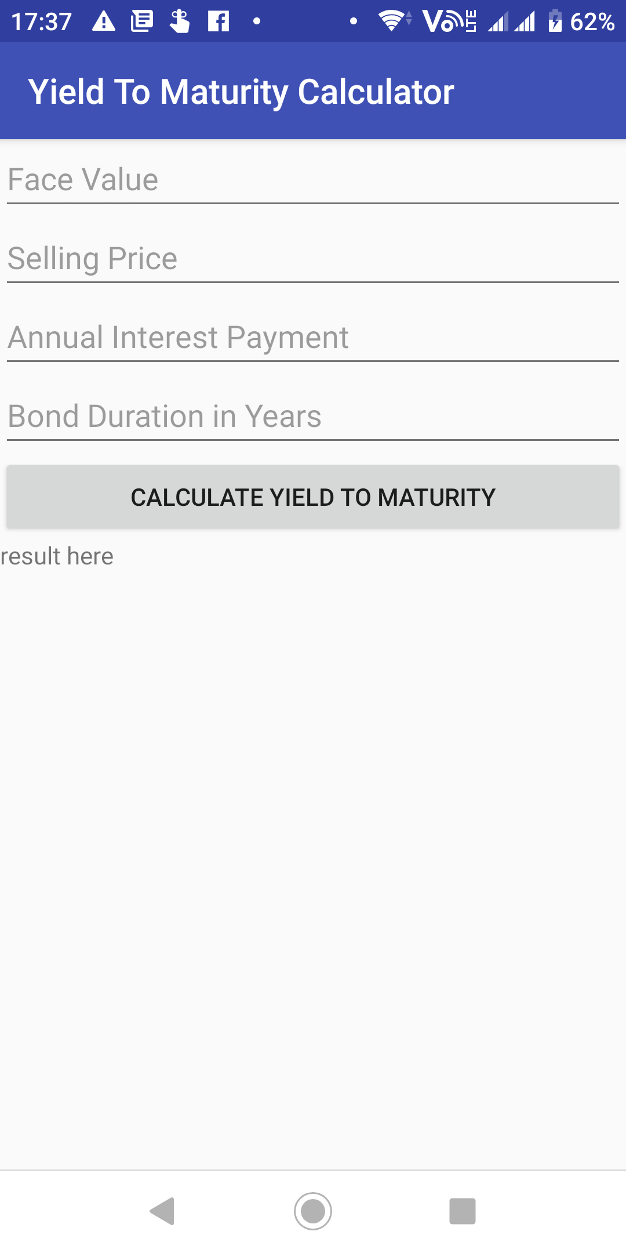

- When the button CALCULATE YIELD TO MATURITY is clicked, values entered into the app are used to calculate the yield to maturity. The yield to maturity is displayed in percentage terms in two decimal places in the widget that currently shows result here.
Use the Bond class written in Part 1 to carry out the calculation.
- If any of the EditText widgets are left blank, a toast should be displayed with an appropriate message. The exact text of the message is left to you to decide.

Write the code in the space given to you in MainActivity.java.

The XML file for the layout above is given below.

<?xml version="1.0" encoding="utf-8"?>
<LinearLayout xmlns:android="http://schemas.android.com/apk/res/android"
xmlns:app="http://schemas.android.com/apk/res-auto"
xmlns:tools="http://schemas.android.com/tools"
android:layout_width="match_parent"
android:layout_height="match_parent"
android:orientation="vertical"
tools:context=".MainActivity">

<EditText
android:id="@+id/editTextFaceValue"
android:inputType="number"
android:hint="Face Value"
android:layout_width="match_parent"
android:layout_height="wrap_content" />

<EditText
android:id="@+id/editTextSellingPrice"
android:inputType="number"
android:hint="Selling Price"
android:layout_width="match_parent"
android:layout_height="wrap_content" />

<EditText
android:id="@+id/editTextAnnualInterest"
android:inputType="number"
android:hint="Annual Interest Payment"
android:layout_width="match_parent"
android:layout_height="wrap_content" />

<EditText
android:id="@+id/editTextDuration"
android:inputType="number"
android:hint="Bond Duration in Years"
android:layout_width="match_parent"
android:layout_height="wrap_content" />

<Button
android:id="@+id/buttonCalculateYield"
android:text="Calculate Yield To Maturity"
android:layout_width="match_parent"
android:layout_height="wrap_content" />

<TextView
android:id="@+id/textViewResult"
android:text="result here"
android:layout_width="match_parent"
android:layout_height="wrap_content" />

</LinearLayout>

import androidx.appcompat.app.AppCompatActivity;

import android.os.Bundle;
import android.view.View;
import android.widget.Button;
import android.widget.EditText;
import android.widget.TextView;
import android.widget.Toast;

public class MainActivity extends AppCompatActivity {

EditText editTextFaceValue;
EditText editTextSellingPrice;
EditText editTextAnnualInterest;
EditText editTextDuration;
Button buttonCalculateYield;
TextView textViewResult;
final String EMPTY_STRING = "";

@Override
protected void onCreate(Bundle savedInstanceState) {
super.onCreate(savedInstanceState);
setContentView(R.layout.activity_main);

}

}

Part C - Your code in Q1
This part is included to give you an idea of what to expect in Final Exam Part 1
and is for your self-study. You do not need to submit this for marking.

- Apart from the builder design pattern, state one other design pattern used in the Bond class in Q1. Justify your answer.

- A customer using your Bond class complains that the interval bisection method requires too many iterations. You are asked to use another numerical method to obtain the solution.

Describe how your program in Q1 can be modified to satisfy the customer’s requirements.
Your answer should describe
    - which parts of MainActivity.java should be modified and how (you may give code snippets)
    - which of the existing classes should be modified (if any)
    - what new classes should be added (if any)

Note: You do not need to give details of the numerical method to be implemented.

